SYSTEM ANALYSIS AND DESIGN DOCUMENT

CONSTRUCTION MATERIAL MANAGEMENT SYSTEM

Document ID | SYSTEM ANALYSIS AND DESIGN-v0.1
Version Number | 0.1
Issue Date | November 12, 2025
Classification | Public

Copyright Notice
© Materio, (2025 – 2026)
All Rights Reserved

The information contained in this document is the property of Materio. No part of this document may be reproduced, stored in a retrieval system, or transmitted in any form, or by any means; mechanical, photocopying, recording, or otherwise, without the prior written consent of Materio. Under the law, copying includes translating into another language or format. Legal action will be taken against any infringement.

The information contained in this document is subject to change without notice and does not carry any contractual obligation for Construction Sites. Cons reserve the right to make changes to any products or services described in this document at any time without notice. Materio shall not be held responsible for the direct or indirect consequences of the use of the information contained in this document.

TABLE OF CONTENTS
Chapter 1: 4
1.Introduction 4
1.1 Purpose 4
1.2 Scope 4
2. Stakeholders Analysis 5
3. The System UI/UX 6
4. System Architecture. 9
5. System Analysis and Design 9

Chapter 1:

1.Introduction

1.1 Purpose
This document focuses mainly on the system architecture data structures, interfaces and other design elements for Construction Material Management System (CMMS), which will streamline the inventory management and distribution of construction materials. Whereby it will help developers and teams effectively plan and implement the system for testing, deployment, updating and maintaining. The second purpose for this tool is to identify the features and capabilities required from it and shows how collaboration and communication is been facilitate thereby improving teamwork, task management, real-time updating and reporting.

1.2 Scope
The system will cover functionalities like:
- Supplier management.
The database will store suppliers’ credentials such as contact details, performance metrics and materials supplied. Then evaluation of suppliers will be done regularly based on criteria such as delivery time, quality, and pricing.

- Reporting and analytics.
Generating of reports will be done on material usage over defined periods to analyze trends and optimize procurement decisions. Supplier performance also have a report that is analysing the supplier efficiency based on delivery time, quality and pricing history. And lastly analysis of cost which helps budgeting and financial planning.

- Order Management
Users purchase orders based on approved material request thereby they track the status of orders with suppliers, including pending, shipped and delivered status.

- Inventory tracking.
Monitoring current stock levels in real time by implementing real-time update. Periodic audits to verify stock levels against recorded data to identify discrepancies should be conducted and automated alerts when items need to be reordered.

- Material requisition.
An approval process should be implemented where requests are reviewed and approved or rejected by Project managers or designated approvers. Request submission is applied for users to submit requests for materials required for construction projects by specifying details such as type, quantity and urgency.

- Hybrid access
Responsive design for mobile and web application for users or clients(contractors) to access the system user friendly thereby enabling them to check inventory through mobile devices and web directly from the construction sites.

- Notifications and Alerts
. The tool will provide features for notifications such as new request, approval, low stock and real-time updates on the dashboard by implementing via email, push-notifications, in-app alerts, and web portal messages which will ensure communication within the Construction Material Management system

Non- functionalities covered by the system include:

- Backup and Recovery.
Daily backups and recovery availability within 2hours after a failure.
- Performance
The system should be able to support 100 current users with a response time of not less than 3seconds.
- Security
User data must be encrypted by using authentication, two-step verification and accessed should be role-based.

2. Stakeholders Analysis
- Admin: Coordinates, manage stocks, Manage user.
- Procurement Officers (Client): Responsible for purchasing materials, contact technician, buy product.
- Visitor: Create account Browse product, browse different technicians listing.
- Technicians: Request for materials needed for work assignments, Manage requests.
- Delivery agent: Manage Delivery.
- Site Supervisor(contractors): Ensures contraction processes are carried out effectively and safely at worksite.
- Finance Team (API): Manages the budgeting, accounting and financial analysis related to construction projects.

3. The System UI/UX
This section shows the UI/UX of the system to be implemented. Whereby, UI is how the user will interact with the system features and UX shows how its flexible, scalable and portable the system is.

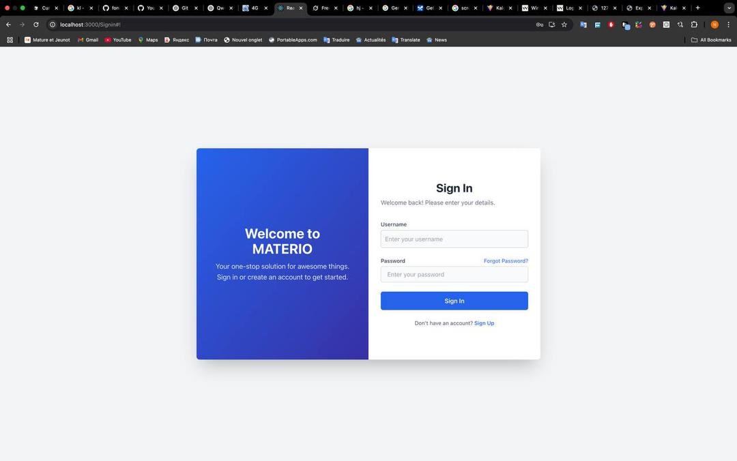
Figure 1: Login page

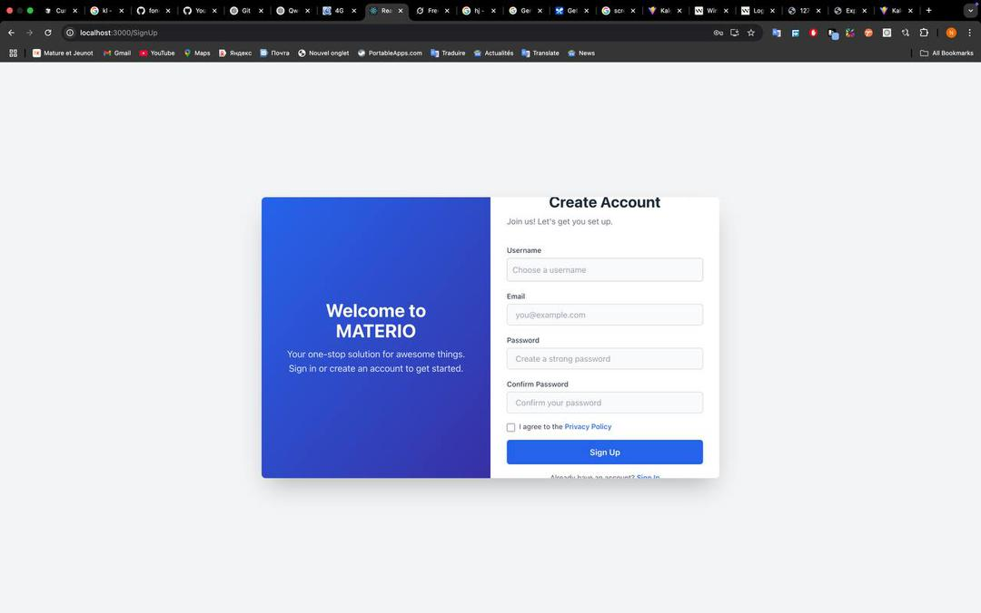
Figure 2.2: Sign up page

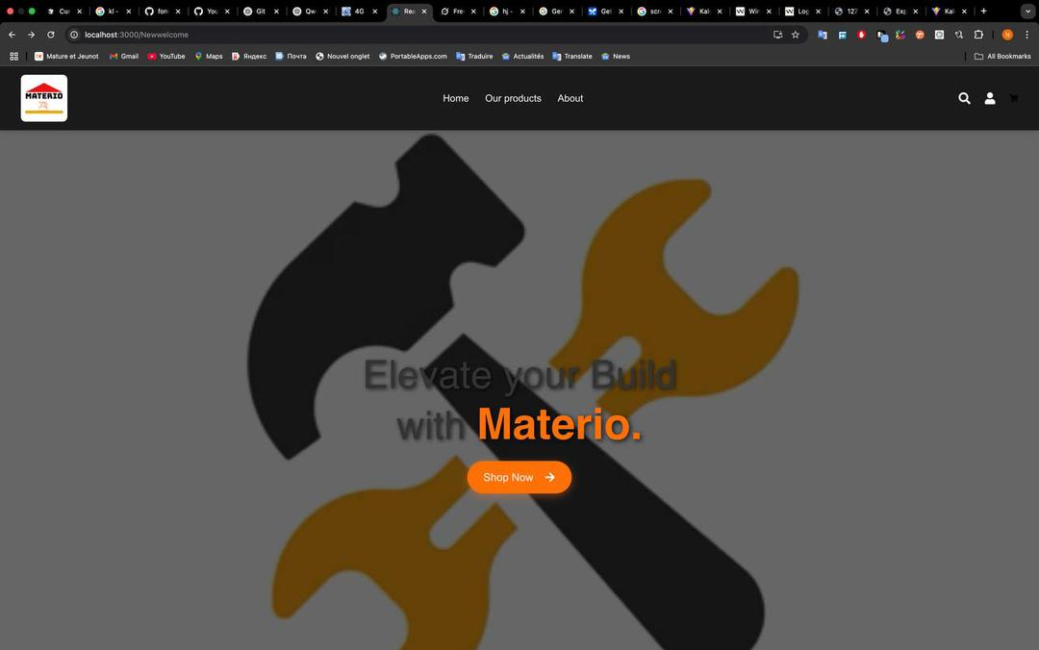
Figure 3: Home page

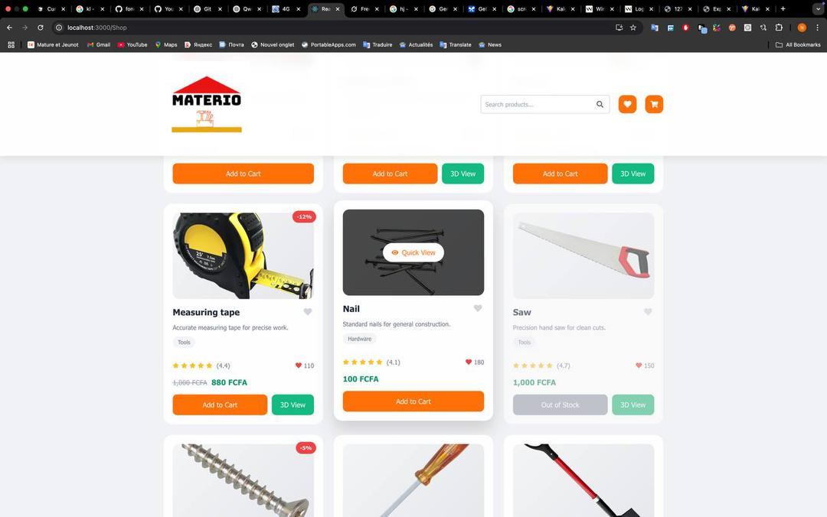
Figure 4: Our product page

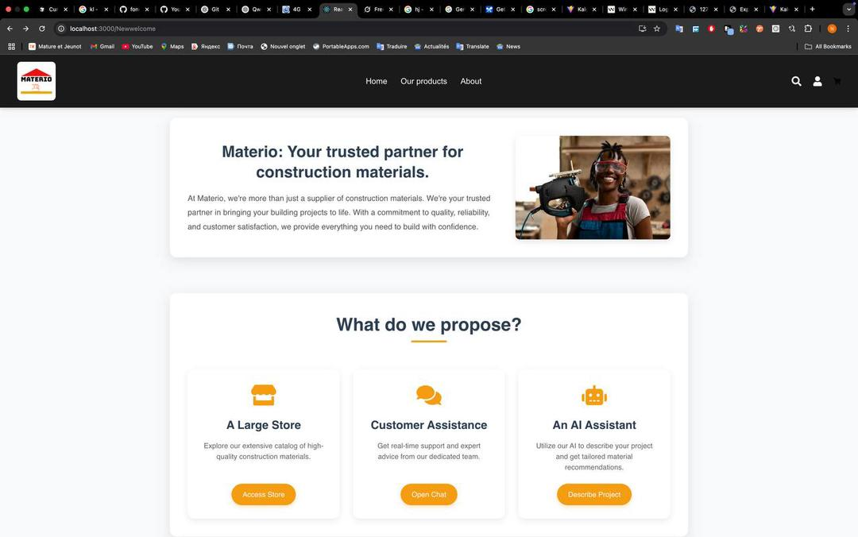
Figure 5: About page

4. System Architecture.
It encompasses the overarching design and organization of the system components, their relationships and how they interact with each other to fulfil the system requirement.

Vertical Container
web App
-
)
React/Django
(
-
mobile App
Business logic
authentication & authorisation
*inventory management
purchase order management
Supplier management
reporting and Analyric
Database layer
mySQL
tables:
materials
supliers
users
deliveries
material_usage
transactions
external
email/sms notification
system
barcode/QR code
Payment gateway
cloud storage
API gateway
(
restful endpoints, routing
)

5. System Analysis and Design

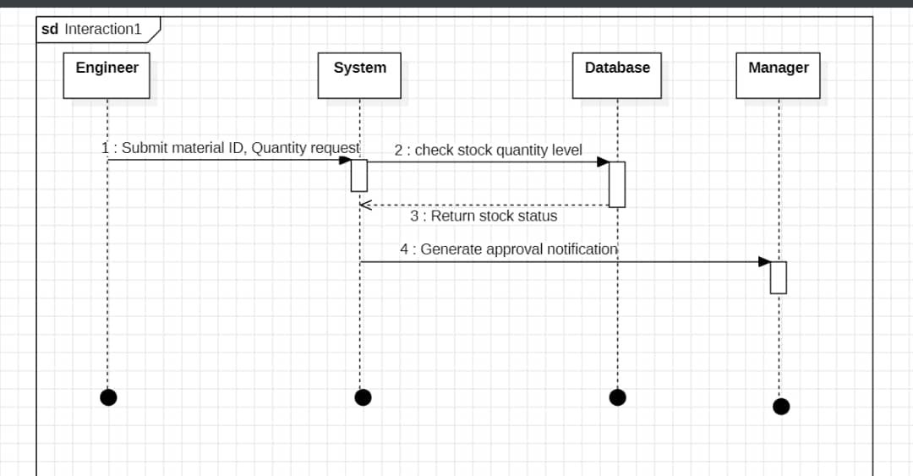

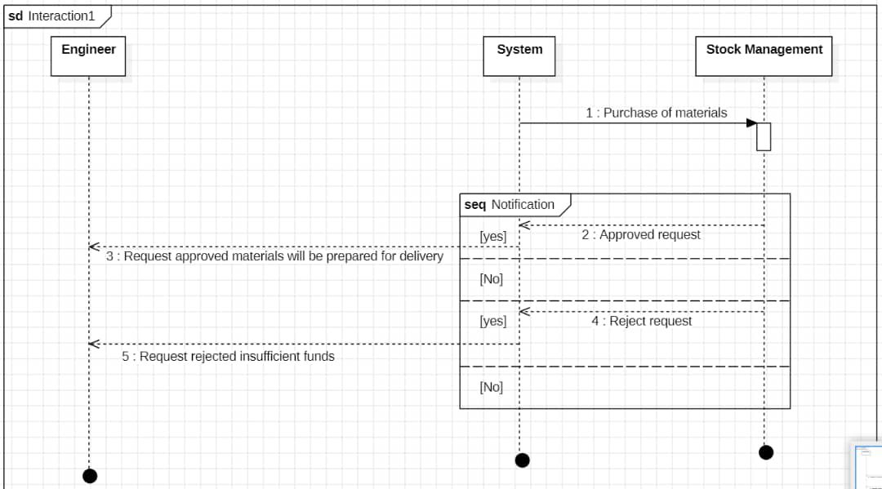

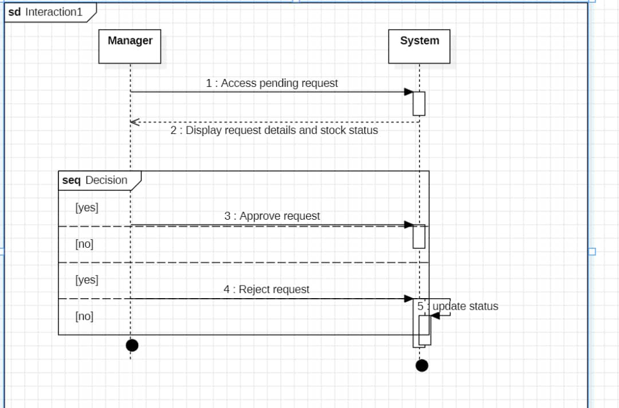
The Materio Class Model Summary
This summary breaks down the system into core components, detailing the attributes, methods for each class and a list of all defined relationships and cardinalities.

- Core Classes, Attributes and Methods

- InventoryType Classes.
CLASS NAME | PRIMARY KEY (PK) / FOREIGN KEY (FK) | ATTRIBUTES | METHODS
Product | - productID: string (PK) | -name: string, -Stockquantity: Integer, - price: double, - category: string | +updateStock()  +getDetails()
Payment | - paymentID: int (PK), orderID: int (FK), | -orderID: int ,  -payDate: date, -payMethod: string, -status: string, -amount: string | +confirmpayment()
DeliveryAgent | - agentID: int (pk)  orderID: int (FK) | -vehicleType: string,  -availability: string,  -orderID: int | +markDelivered()
Order | - orderID: int (PK)  - userID: int (FK) | - orderID: int ,  - userID: int ,  - orderDate: date, - amount: double, - deliveryID: int, - deliveryDate: date, | +placeOrder()
OrderItems | -orderItemID: int (PK), orderID: int (FK), -productID: string (FK) | -orderID: int ,  -productID: string ,  -quantity: int,  -unitPrice: double | +getDetails()

- User Classes
CLASS NAME | PRIMARY KEY (PK) / FOREIGN KEY (FK) | ATTRIBUTES | METHODS
User | #userID: int (PK) | #name: string, #email: string,  #role: string  #password: string | +register(), +login(), +updateProfile()
Admin | -userID: int (FK) |  | +SuspendUser(), +addUser(), updateUser()
Client | -userID: int (FK) |  | +getDetails()
Technician | - techID: int (PK) | - speciality: int  - techName: string, - CNInum: int | +viewProfile()

- Analytic and Insight Classes
CLASS NAME | PRIMARY KEY (PK) / FOREIGN KEY (FK) | ATTRIBUTES | METHODS
Notification | -notyID: int (PK)  -userID: int (FK) | -messageAlert: string,  -date: Date | +sendNotification()
ServiceRequest | -userID: int (FK)  -requestID: int (PK)  -techID: int (FK) | -requestDate: date,  -message: string,  -status: string | -submitRequest()

- Relationships and Cardinalities
This section details how the classes are linked together, by representing the structural rules of the system.
Relationship(source-> target) | Type of Relationship | Source Cardinality | Target Cardinality | Description
Product -> OrderItem | Composition | 1..1 | 1..*
Order->OrderItem | Composition | 1..1 | 1..* | An order contain one or multiple order items.
Order->Payment | Aggregation | 1..1 | 1..1 | An order have a payment
DeliveryAgent->Order | Association | 1..1 | 1..* | A delivery agent is assign to one or multiple order.
Client->Order | Aggregation | 1..1 | 0…* | A client can place zero or many order
Client->ServiceRequest | Aggregation | 1..1 | 0..* | A client can send zero or multiple service request.
ServiceRequest->Technician | Association | 1..* | 1..1 | One or many service requests can be address to a technician.
User->Notification | Association | 1..1 | 0..* | A client can receive zero or multiple notifications.

CLASS DIAGRAM

All Rights Reserved

